**A Heart-Healthy Lifestyle**

Each February, we celebrate Valentine’s Day—and American Heart Month. Heart disease is the Number 1 killer of both men and women in the United States, so it is important to focus on heart health not just this month, but throughout the year.

The National Heart, Lung and Blood Institute lists five keys to a heart-healthy lifestyle:

1. **Be active**

You need daily physical activity to increase your length and quality of life. Physical activity can be as simple as brisk walking for 30 minutes a day, five days a week, or that household cleaning you do to avoid your workout. In fact, physical activity is any body movement that works your muscles and requires more energy than resting.

A study by the U.S. Office of Disease Prevention and Health Promotion says there is strong evidence demonstrating a significant relationship between greater amounts of physical activity and decreased incidence of cardiovascular disease, stroke, and heart failure, and other studies show a relationship between physical activity and reduced incidents of diabetes.

**What To Do**

Start by learning the [basics about fitness](https://www.goredforwomen.org/live-healthy/heart-healthy-exercises/fitness-basics/). While some health benefits begin with as little as 60 minutes (1 hour) a week, 150 minutes (30 minutes per day for 5 days) consistently each week of moderate-intensity aerobic activity, such as brisk walking, reduces the risk of many chronic diseases and other adverse health outcomes. Check out the Health.Gov guidelines for Physical Activity at <https://health.gov/paguidelines/guidelines/chapter2.aspx>.

1. **Eat Healthy**

Heart-healthy eating involves consuming vegetables, fruits, whole grains, fat-free or low-fat dairy products, fish, lean meats, poultry, eggs, nuts, seeds, soy products, legumes, and vegetable oils (except coconut and palm oils). Also, it limits sodium, saturated and trans fats, added sugars, and alcohol.

**What To Do**

The following foods are the foundation of a heart-healthy diet

* Vegetables such as greens (spinach, collard greens, kale), broccoli, cabbage, and carrots
* Fruits such as apples, bananas, oranges, pears, grapes, and prunes
* Whole grains such as plain oatmeal, brown rice, and whole-grain bread or tortillas
* Fat-free or low-fat dairy foods such as milk, cheese, or yogurt
* Protein-rich foods such as Omega-3-rich fish, lean meats, eggs, nuts, seeds, soy products and legumes.
* Oils and foods containing high levels of monounsaturated and polyunsaturated fats, such as Canola, corn, olive, safflower, sesame, sunflower, and soybean oils

You should eat the right amount of calories for your body, which will vary based on your sex, age, and physical activity level. Find out your daily calorie needs or goals with the [Body Weight Planner](https://www.supertracker.usda.gov/bwp/index.html).

1. **Maintain a Healthy Weight**

The more body fat that you have and the more you weigh, the more likely you are to develop coronary heart disease, high blood pressure, type 2 diabetes, breathing problems, and certain cancers.

A healthy weight for adults is usually when your body mass index (BMI) is between 18.5 and 24.9. To figure out your BMI, use the National Heart, Lung, and Blood Institute’s online [BMI calculator](https://www.nhlbi.nih.gov/node/24054) and compare your BMI with the following table.

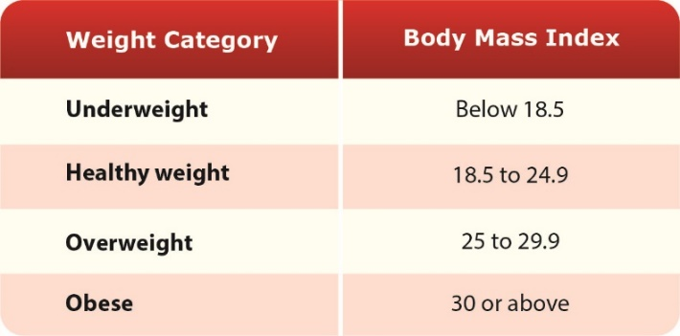

**What To Do**

If you are overweight or obese, try to lose weight. A loss of just 3 to 5 percent of your current weight can lower triglycerides and glucose levels in your blood and reduce your risk of developing type 2 diabetes. Losing more than 3 to 5 percent of your weight can improve blood pressure readings, lower bad LDL cholesterol, and increase good HDL cholesterol.

Talk to your doctor or healthcare provider about what BMI is right for you. Follow a heart-healthy eating plan and be physically active to help achieve and maintain a healthy weight.

1. **Manage Stress**

Emotionally upsetting events—particularly those involving anger—can serve as a trigger for a heart attack or angina in some people. Stress can contribute to high blood pressure and other cardiovascular risks. Some of the ways people cope with stress—drinking alcohol, abusing other substances, smoking, or overeating—are not healthy ways to manage stress.

Learning how to manage stress and cope with problems can improve your emotional and physical health. Consider healthy stress-reducing activities such as:

* Being physically active (a recurring theme)
* Participating in a stress management program
* Practicing meditation
* Trying relaxation therapy
* Talking with friends, family, and community or religious support systems
* Visiting a qualified mental healthcare provider

**What To Do**

Use the tools HBC provides to ALL Associates to help manage stress and improve your mental health, including:

* Optum Employee Assistance Program (EAP)

Associates and their dependents can access the EAP 24 hours a day, seven days a week via a toll free phone number or the Web. The EAP provides up to five confidential, in-person sessions with a counselor, at no cost to you. The assistance is completely confidential.

CALL TOLL FREE (866) 248-4094 or VISIT [WWW.LIVEANDWORKWELL.COM](https://www.liveandworkwell.com/content/en/public.html) AND USE ACCESS CODE **HBC**

* Watch [MINDFRESH TV](http://mindfresh.uscreen.io/) videos, which can be done in less than five minutes where ever you have internet access! Videos focus on topics such as avoiding emailing when angry, staying focused, boosting your confidence and interacting with coworkers, just to name a few!

Visit [TV.Mindfresh.co](http://mindfresh.uscreen.io/) and sign in with the following credentials:

Email: hbc@mindfresh.co Password: mindfresh

1. **Stop smoking**

Cigarette smokers have a higher risk of developing cardiovascular disease. If you smoke, quitting is the best thing you can do for your health. Smoking damages your entire circulatory system, and increases your risk for coronary heart disease, hardened arteries, aneurysm and blood clots. Smoking can also reduce your good cholesterol (HDL) and your lung capacity, making it harder to get the physical activity you need for better health.

**What To Do**

**Whatever it takes** for you to stop smoking, it is worth it! It can be hard, but millions of people have successfully quit smoking and remain nonsmokers. Surveys of current adult smokers find that 70 percent say they want to quit.

Visit the [National Institutes for Health (NIH) Smoking and Your Heart](https://www.nhlbi.nih.gov/health-topics/smoking-and-your-heart) website for tips on Quitting Smoking. Or see your physician.